Bangladesh Medical Association (BMA)
List of Life Member-62
01. BMA Bagerhat Branch

Sl No | Voter No | Voter Details
1 | Voter No  LM-0100001  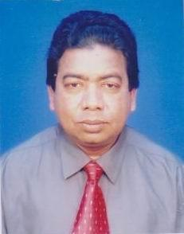 | DR. S.M. LUTFUL KABIR  F/Name:  M/Name:  BM & DC Reg. No:  NID:  Cell:  Address: Medical Officer,. Upazilla Health Complex, Bagerhat.  Blood Group:
2 | Voter No  LM-0100002  No Image | DR. S.M. SHAHABUL KARIM  F/Name:  M/Name:  BM & DC Reg. No:  NID:  Cell:  Address: BSMMU., 717, Block-A, Shahbag, Dhaka.  Blood Group:
3 | Voter No  LM-0100003  No Image | DR. SALEHA KHATOON  F/Name:  M/Name:  BM & DC Reg. No:  NID:  Cell:  Address: 57, Amlapara Bagerhat  Blood Group:
4 | Voter No  LM-0100004  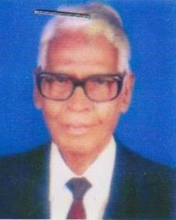 | DR. S. M. A. LATIF  F/Name: Late S.m.a. Fazuddin  M/Name:  BM & DC Reg. No:  NID:  Cell:  Address: Health Home Sarai Road, Amlapara, Bagerhat.  Blood Group:
5 | Voter No  LM-0100005  No Image | DR. NAIMA FERDOUSI  F/Name: Sk. Walior Rahman  M/Name:  BM & DC Reg. No:  NID:  Cell:  Address: Shaltala, Bagerhat.  Blood Group:
6 | Voter No  LM-0100006  No Image | DR. SK. A. KAYYUM  F/Name: Sk. A. Rashid  M/Name:  BM & DC Reg. No:  NID:  Cell:  Address: Sadar Hospital, Bagerhat  Blood Group:
7 | Voter No  LM-0100007  No Image | DR. MD. MAHBUBUL ISLAM  F/Name: Md. Abdus Sattar Munshi  M/Name:  BM & DC Reg. No: 11526  NID:  Cell:  Address: Sadar Hospital, Bagerhat.  Blood Group:
8 | Voter No  LM-0100008  No Image | DR. MD. ABUL KALAM AZAD  F/Name: Kanchan Ali Talukder  M/Name:  BM & DC Reg. No:  NID:  Cell:  Address: Sadar Hospital, Bagerhat.  Blood Group:
9 | Voter No  LM-0100009  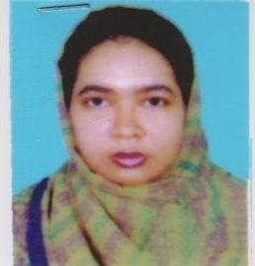 | DR. JESMIN SULTANA  F/Name:  M/Name:  BM & DC Reg. No:  NID:  Cell:  Address: Eid Ghah Road Nager Bazer, Bagerhat.  Blood Group:
10 | Voter No  LM-0100010  No Image | DR. ELMA AKHTER  F/Name:  M/Name:  BM & DC Reg. No:  NID:  Cell:  Address: Holding No.179 South Mithopukurper, Bagerhat.  Blood Group:
11 | Voter No  LM-0100011  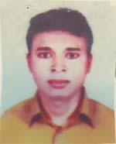 | DR. MANOJ KUMAR MALAKAR  F/Name:  M/Name:  BM & DC Reg. No: 38785  NID: 2694810975990  Cell: 01715296167  Address: UHC, Morrelganj, Bagerhat  Blood Group: O-  TRANSFERED to BMA Dhaka City  LM-1405543
12 | Voter No  LM-0100012 | DR. SHAIKH MD. JAKARIA  F/Name: Shaikh Md. Siddique Ali  M/Name: Salma Parvin  BM & DC Reg. No: 37716  NID: 0113484143381  Cell: 01740899506  Address: Medical Officer, Civil surgeon office, Bagerhat  Blood Group: A+
13 | Voter No  LM-0100013 | DR. KAMAL HOSSAIN MUFTY  F/Name: Abdul Latif Mufty  M/Name: Begum Faizun Nessa  BM & DC Reg. No: 43065  NID: 2696406683770  Cell: 01914859741  Address: Hospital Quarter, UHC, Morrelgonj, Bagerhat  Blood Group: O+
14 | Voter No  LM-0100014 | DR. SHEKHAR CHANDRA DAS  F/Name: Ashoke Kumar Das  M/Name: Ramala Das  BM & DC Reg. No: 16318  NID: 0120808134251  Cell: 01715001118  Address: Sadar Hospital Bagerhat, Junior Consultant (Pedi)  Blood Group: B+
15 | Voter No  LM-0100015 | DR. TAPAS KUMAR DAS  F/Name: Late Sharaz Chandra Das  M/Name: Shreemati Bala Das  BM & DC Reg. No: 30967  NID: 0113876491542  Cell: 01711351891  Address: Uhs, Kachua, Bagerhat  Blood Group: A+
16 | Voter No  LM-0100016 | DR. SHANKER KUMAR DAS  F/Name: Late Tarapada Das  M/Name: Saraswati Das  BM & DC Reg. No: 25434  NID: 0110894303487  Cell: 01711953227  Address: Vill-Saira, Post-Saira, Thana+Dist-Bagerhat  Blood Group: O+  E X P I R E D
17 | Voter No  LM-0100017 | DR.SHARUP CHANDRA PODDAR  F/Name: Manoranjan Poddar  M/Name: Santi Rani Poddar  BM & DC Reg. No: 52043  NID: 0115647961395  Cell: 01717304901  Address: Medical officer, UHC, Mollahat, Bagerhat  Blood Group: B+
18 | Voter No  LM-0100018  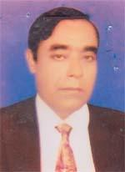 | DR. SYED JAHANGIR HOSSAIN  F/Name: Late Syed Golam Rahman  M/Name: Late Ayesha Rahman  BM & DC Reg. No: 17522  NID: 0125807344499  Cell:  Address: RMO, Upazilla Health Complex, Mollahat, Bagerhat  Blood Group: B+
19 | Voter No  LM-0100019 | DR. FARZANA SHARMIN  F/Name: Md. Abdur Rouf  M/Name: Rehana Begum  BM & DC Reg. No: 52392  NID: 3323011305967  Cell: 01829128648  Address: Vill+Post-Dashani, P.s+Dist-Bagerhat  Blood Group: AB+
20 | Voter No  LM-0100020  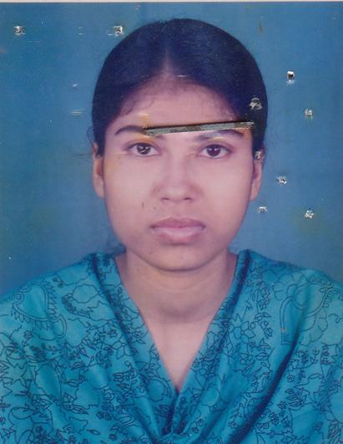 | DR. BINA RANI DEY  F/Name: Birendra Chandra Dey  M/Name: Maya Rani Dey  BM & DC Reg. No: 48137  NID: 2694067816201  Cell: 01929589596  Address: Upazilla Health Complex, Kachua, Bagerhat  Blood Group: O+
21 | Voter No  LM-0100021 | DR. TAPATI PADDER  F/Name: Sunil Kumar Padder  M/Name: Tulshi Padder  BM & DC Reg. No: 51704  NID: 2691648463845  Cell: 01715145433  Address: Vill-Charkathi, Post-Charkathi, Upazilla-Kachua, Dist-Bagerhat  Blood Group: B+
22 | Voter No  LM-0100022 | DR. SWAPAN KUMAR TAPADER  F/Name: Sudhir Kumar Tapader  M/Name: Late Shanti Sudha Tapader  BM & DC Reg. No: 11548  NID: 90243829224  Cell: 01716283066  Address: Civil Surgeon office, Bagerhat  Blood Group: n_a
23 | Voter No  LM-0100023 | DR. ANIL KUMAR KUNDU  F/Name: Late Sureudra Nath Kundu  M/Name: Late Soura Bala Kaudu  BM & DC Reg. No: 18610  NID: 2691648087515  Cell: 01711668448  Address: Mother and Child Welfare Centre, Bagerhat  Blood Group: B+
24 | Voter No  LM-0100024  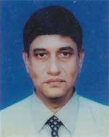 | DR. BIDUYTH KANTI PAUL  F/Name: Late Bisaw Nath Paul  M/Name: Late Sarala Bala Paul  BM & DC Reg. No: 16739  NID: 0120806127057  Cell:  Address: UHFPO, Sadar UHC, Bagerhat  Blood Group: B+
25 | Voter No  LM-0100025  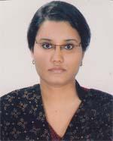 | DR. SADIA TAHSIN  F/Name: A. F. M. Mahbubul Ahsan  M/Name: Nasrin Ahsan  BM & DC Reg. No: 54955  NID: 479851723365  Cell: 01717411742  Address: 2, Amlapara Main Road, Bagerhat, 9300  Blood Group: B+
26 | Voter No  LM-0100026  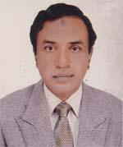 | DR. RAFIQUL ALAM  F/Name: Sikder Rustom Ali  M/Name: Late Hosne Ara Begom  BM & DC Reg. No: 12134  NID: 0120804115311  Cell: 01711830936  Address: Medical Assistant Traing School, Bagerhat  Blood Group: B+
27 | Voter No  LM-0100027 | DR. SHAWON SHAHRIAR  F/Name: Rafiqul Alam  M/Name: Quhalee Begum  BM & DC Reg. No: 54954  NID: 4798516214677  Cell: 01717495059  Address: 2, Amlapara, Main Road, Bagerhat  Blood Group: B+
28 | Voter No  LM-0100028  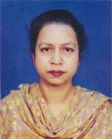 | DR. QUHALEE BEGUM  F/Name: Late Sirajul Islam  M/Name: Mrs. Nurunnesa Khanam  BM & DC Reg. No: 12423  NID: 0120804115310  Cell: 01711397551  Address: Sadar Hospital, Bagerhat-9300  Blood Group: A+
29 | Voter No  LM-0100029 | DR. SAMIR KANTI PAUL  F/Name: Late Sunil Krishana Paul  M/Name: Mrs. Iila Rani Paul  BM & DC Reg. No: 16.140  NID: 0120802108025  Cell: 01716153966  Address: Junior Lectute, Medical Asst. Traning School, Bagerhat  Blood Group: O+
30 | Voter No  LM-0100030  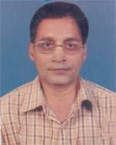 | DR. MONWARUL ISLAM  F/Name: Late Prof. Nurul Islam  M/Name: Noorjahan Begum  BM & DC Reg. No: 29744  NID: 0120806129474  Cell: 01712180934  Address: 51/2, Munigonj Malopara Road, Bagerhat  Blood Group: B-
31 | Voter No  LM-0100031  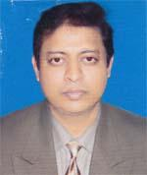 | DR. A K M NAZRUL ISLAM FARUQUI  F/Name: Late Abul Kalam Azad Faruqui  M/Name: Late Mst. Rahima Begum  BM & DC Reg. No: 44618  NID: 0116065841298  Cell: 01716422062  Address: Vill-West Sharalia, Post+P.s+Upazilla-Morrwlgonj, Dist-Bagerhat  Blood Group: A+
32 | Voter No  LM-0100032  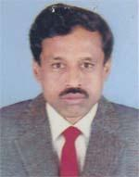 | DR. UDAY BARAN MONDAL  F/Name: Late Sannyashi Kumar Mondal  M/Name: Late Hem Lata Mondal  BM & DC Reg. No: 15960  NID:  Cell: 01820531188  Address: Vill-Gorablai, Post-Uccotmary, P.s-Rampal, Dist-Bagerhat  Blood Group: B+
33 | Voter No  LM-0100033  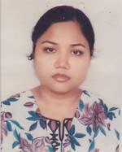 | DR. AFSANA AKHTER  F/Name: Akhter Farukuzzaman  M/Name: Shah Sanjida Alam  BM & DC Reg. No: 49644  NID: 0120806124227  Cell: 01712212577  Address: Amlapara, Bagerhat  Blood Group: A+
34 | Voter No  LM-0100034  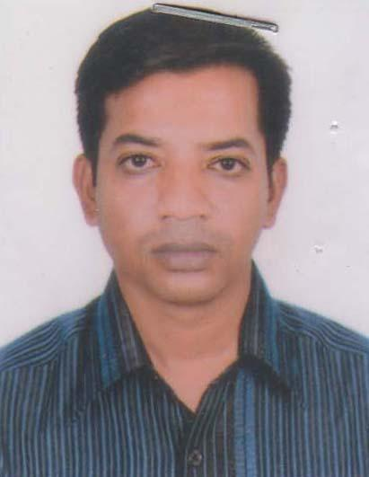 | DR. RAZIB KRISHNA MANDAL  F/Name: Nirmal Chandra Mandal  M/Name: Samita Rani Mandal  BM & DC Reg. No: 47466  NID: 0126005698232  Cell: 01722888965  Address: Vill-Morrelgonj, (Sherestadardari), Post+Upazilla-Morrelgonj, Dist-Bgerhat  Blood Group: B+
35 | Voter No  LM-0100035  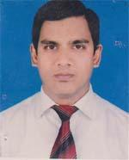 | DR. MD. KHURSHID PARVEZ  F/Name: Md. Rafiquzzaman  M/Name: Khurshid Jahan  BM & DC Reg. No: 51592  NID: 3223011305946  Cell: 01911524493  Address: Vill+Post-Dashani, P.s+Dist-Bagerhat  Blood Group: B-
36 | Voter No  LM-0100036  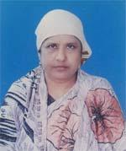 | DR. NAZMUN NESSA  F/Name: Late A. M. Nazem Ali  M/Name: Late Asia Khatun  BM & DC Reg. No: 7692  NID: 0120801101275  Cell: 01711067324  Address: 43/5, Munigonj Main Road, Bagerhat  Blood Group: O+
37 | Voter No  LM-0100037  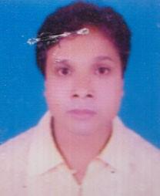 | DR. ASIM KUMAR SAMADDER  F/Name: Neronjon Behari Samadder  M/Name: Pushpa Rani Samadder  BM & DC Reg. No: 29435  NID: 011604792771  Cell: 0179265444  Address: UHC, Morrelgonj, Bagerhat  Blood Group: A+
38 | Voter No  LM-0100038  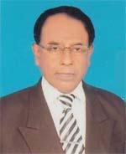 | DR. MD. SHIBBIR AHMED  F/Name: Tazammal Hossain  M/Name: Sakina Hossain  BM & DC Reg. No: 12532  NID: 0126007706087  Cell: 01715071717  Address: UHC, Morrelganj, Bagerhat  Blood Group: A+
39 | Voter No  LM-0100039 | DR. SK. MD. MOSHARRAF HOSSAIN  F/Name: Sk. Md. Akman Ali  M/Name: Late Amina Begum  BM & DC Reg. No: 33420  NID: 2694813880211  Cell: 01914466764  Address: Medical officer, Sadar Hospital, Bagerhat  Blood Group: A+
40 | Voter No  LM-0100040  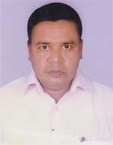 | DR. MD. SERAJUL HOQUE  F/Name: Late Md. Dabir Uddin Shaikh  M/Name: Mosa. Motiunnesa  BM & DC Reg. No: 23.816  NID: 0110851227817  Cell:  Address: Deshary Bhaban, 43/1, Paurosava Road, Bagerhat, Bagerhat  Blood Group: AB+
41 | Voter No  LM-0100041  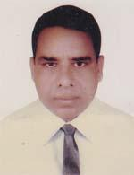 | DR. MOLLA EMDADUL HAQUE  F/Name: Late Md. Hossain Molla  M/Name: Late Gul E Har Mohammad  BM & DC Reg. No: 13005  NID: 0120801101433  Cell: 0171397538  Address: Doctors Clinic, Bagerhat  Blood Group: O+
42 | Voter No  LM-0100042  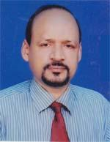 | DR. MAHESH CHANDRA DHALI  F/Name:  M/Name:  BM & DC Reg. No: 18978  NID: 010035119404  Cell: 01711668236  Address: Sadar Hospital, Bagerhat  Blood Group: B+  TRANSFERED to BMA Dhaka City  LM-1405543
43 | Voter No  LM-0100043 | DR. ABU DAWOOD KHAN MD. YAHYA  F/Name: Late Md. Abdul Jabbar Khan  M/Name: Mrs. Hosneara Begum  BM & DC Reg. No: 29287  NID: 0120806126770  Cell: 01711125159  Address: Rail Road, Bagerhat  Blood Group: n_a
44 | Voter No  LM-0100044  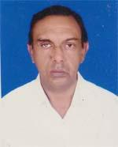 | DR. MD. SHAHIDUL ISLAM  F/Name: Late Siddiqur Rahman  M/Name: Mrs. Fazila Khatun  BM & DC Reg. No: 9216  NID: 0120805121133  Cell: 01715292841  Address: Puratan Bazar, Bagerhat  Blood Group: O+
45 | Voter No  LM-0100045 | DR. SABRINA MOHONA  F/Name: Dr. Md. Mosharraf Hossain  M/Name: Dr. Husne Ara Khatun  BM & DC Reg. No: 51855  NID: 2696653243235  Cell: 01765006434  Address: Niramoy Diagnostic, Puratan Bazar, Bagerhat  Blood Group: AB+
46 | Voter No  LM-0100046  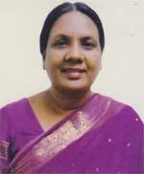 | DR. HUSNE ARA KHATUN  F/Name: Md. Babar Ali  M/Name: Hazera Khatun  BM & DC Reg. No: 10770  NID:  Cell: 01711348489  Address: Puratan Bazar, Bagerhat  Blood Group: A+
47 | Voter No  LM-0100047 | DR. TARIKUL ISLAM  F/Name: Mr. Munsur Ahmed  M/Name: Late Ms. Helena Begum  BM & DC Reg. No: 47806  NID: 0120804119519  Cell: 01745447997  Address: Puraton Bazar, Bagerhat  Blood Group: O-
48 | Voter No  LM-0100048  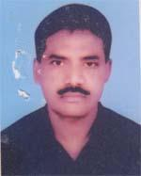 | DR. ANUP KUMAR BISWAS  F/Name: Atul Chandra Biswas  M/Name: Sudha Rani Biswas  BM & DC Reg. No: 11827  NID: 0120806127370  Cell: 01711397540  Address: Konica Clinic, Rail Road, Bagerhat  Blood Group: O+
49 | Voter No  LM-0100049  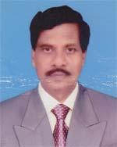 | DR. MD. NAZRUL ISLAM  F/Name: A. T. M. Ajahar Ali (late)  M/Name: Rahila Begum (late)  BM & DC Reg. No: 15993  NID: 0120802108215  Cell: 01711279563  Address: 30/3, P.C College Road, Bagerhat, Post+Thana+Dist-Bagerhat  Blood Group: O+
50 | Voter No  LM-0100050  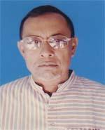 | DR. ABDUL MATIN AKON  F/Name: Late Eman Ali Akon  M/Name: Late Asia Begume  BM & DC Reg. No: 7695  NID:  Cell: 01712280460  Address: Alia Madrasha Road, Bagerhat  Blood Group: B+
51 | Voter No  LM-0100051 | DR. MD. MOSHARRAF HOSSAIN MUKTO  F/Name: Al Haj A Aziz Howlader  M/Name: Monowara Begum  BM & DC Reg. No: 10769  NID: 0120804117622  Cell: 01711217077  Address: Puratan Bazar Rd, Bagerhat 9300  Blood Group: B+
52 | Voter No  LM-0100052  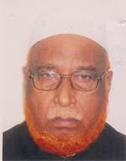 | DR. AL- HAJ MOZZAMAL HOSSAIN  F/Name: Late Alhaj Rahamat Ali  M/Name: Late Mir Moyful Begome  BM & DC Reg. No: 4334  NID:  Cell: 01715549590  Address: Amlapara, Bagerhat  Blood Group: n_a  E X P I R E D
53 | Voter No  LM-0100053 | DR. JUHIRUL ISLAM  F/Name: Mr. Nuruzzaman Bapare  M/Name: Mrs. Rabeya Begum  BM & DC Reg. No: 59063  NID:  Cell: 01711301721  Address: Govt. Officer Building, Consultant Block, Ground Floor, Bagerhat Sadar Hospital  Blood Group: O+
54 | Voter No  LM-0100054 | DR. SAGAR BISWAS  F/Name: Debasis Biswas  M/Name: Shabita Biswas  BM & DC Reg. No: 2713  NID: 2696654364751  Cell: 01717004956  Address: 90, K-Ali Road (Beside Of Fire Service), Bagerhat  Blood Group: A+
55 | Voter No  LM-0100055  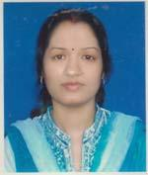 | DR. BASONA RANI MOHANTA  F/Name: Benu Mohanta  M/Name: Shefali Mohanta  BM & DC Reg. No: 3281  NID: 1023308852928  Cell: 01712152017  Address: 90, K-Ali Road (Beside Of Fire Service)  Blood Group: A+
56 | Voter No  LM-0100056 | DR. SAYEED AHMED  F/Name: Faruque Ahmed  M/Name: Rashida Begum  BM & DC Reg. No: 40821  NID: 0120802106157  Cell: 01716434521  Address: Sukher Nir, Paikbari Road, Horinkhana, Sadar, Bagerhat  Blood Group: B+
57 | Voter No  LM-0100057 | DR. ZINNIA FERDOUS  F/Name: Abdul Khaleque  M/Name: Lutfunnahar  BM & DC Reg. No: 57990  NID: 19862650898261056  Cell: 01712841793  Address: Sukher Nir, Paikbari Road, Horinkhana, Sadar, Bagerhat  Blood Group: O+
58 | Voter No  LM-0100058 | DR. SHAIKH RIADUZ ZAMAN  F/Name: Shaikh Sayedur Rahman  M/Name: Kohinoor Rahman  BM & DC Reg. No: A62188  NID: 19892924709173359  Cell: 01835941820  Address: Sorai Madrasha Road, Post+Dist: Bagerhat  Blood Group: O+
59 | Voter No  LM-0100059  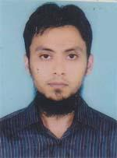 | DR. MD. MIRAJUL KARIM  F/Name: Md. Rezaul Karim  M/Name: Vikarunnesa  BM & DC Reg. No: 53738  NID: 3323021486320  Cell: 01913321987  Address: 12/2 Harikhali Main Road, P.O: PC College, Bagerhat  Blood Group: O+
60 | Voter No  LM-0100060  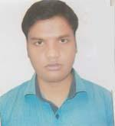 | SHAIKH IMRAN MOHAMMAD  F/Name: Shaikh Ali Akbar  M/Name: Ainur Nahar  BM & DC Reg. No: A65061  NID: 8198510365773  Cell: 01717602988  Address: Vill: East Saira, Post: Saira, P.S: Bagerhat, Dist: Bagerhat  Blood Group: AB+
61 | Voter No  LM-0100061  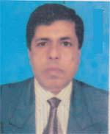 | DR. ARUN CHANDRA MONDAL  F/Name: Jagadish Chandra Mondal  M/Name: Mukhyada Rani Mondal  BM & DC Reg. No: 14191  NID: 0111447044281  Cell: 01711455624  Address: Sonatala, Bagerhat  Blood Group: B+
62 | Voter No  LM-0100062 | DR. TAPAN KUMAR SHIL  F/Name: Late. Rajendra Nath Shil  M/Name: Late. Parul Rani Shil  BM & DC Reg. No: 8233  NID: 0120806126351  Cell: 01927801080  Address: 8, Khanjahan Ali Road, Bagerhat  Blood Group: O+

